EASTERN INTERNATIONAL UNIVERSITY Practice Assignment – Quarter 2, 2023-2024
SCHOOL OF COMPUTING Course Name: OOP
AND INFORMATION TECHNOLOGY Course Code: CSE 203
Student’s Full Name:
Lab 1
Student ID:
- Go to https://app.diagrams.net/ or https://www.lucidchart.com/pages/ (the following steps are used with app.digrams.net, lucidchart can be the same)
- Create account or login
- Select location to save your diagrams (can choose Google Drive for later revising)
- Go to View and turn off Grid for having a clearer view
- Go to UML category on the left side bar, drag and drop Class template to working space
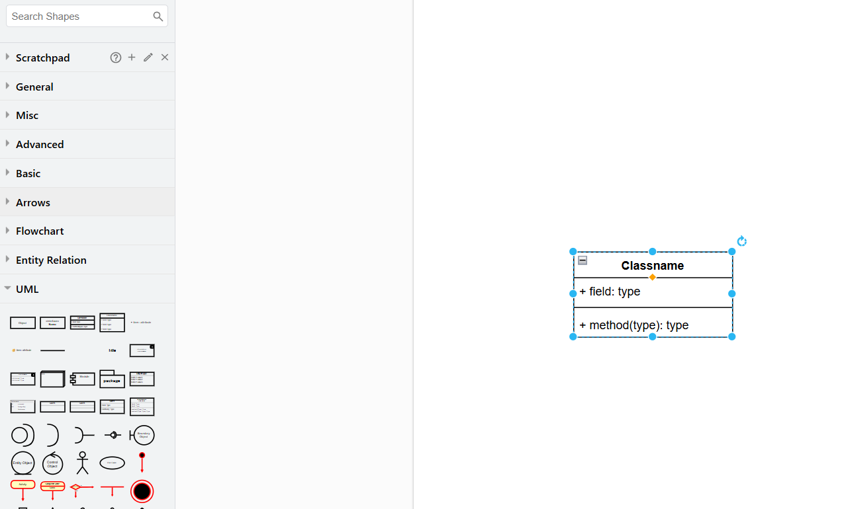
Drop here.
Drag this template (Class)
Go to this section.
- Implement the UMLs for all classes (Customer, Car and ServiceQuote) presented in the lecture slides
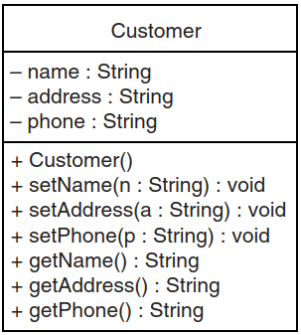
Class name.
Class methods with parameters and return type.
Attributes with data type.
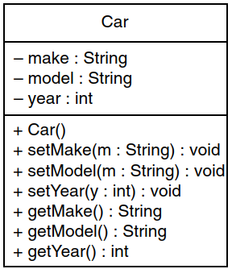
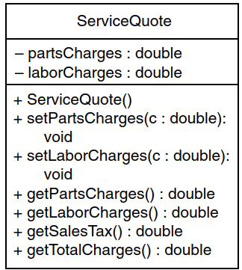
- Repeat the steps for identifying classes, their attributes methods and drawing the UML for those classes in the following problems:

Problem 0:

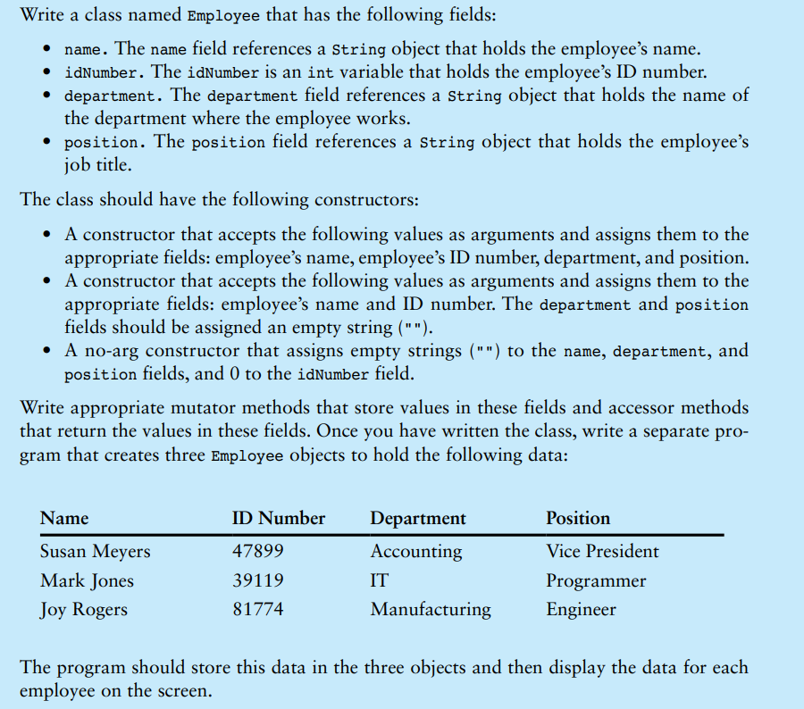
Problem 1:
Bella’s Pet Grooming Shop specializes in grooming dogs and cats. When a customer brings a pet to the shop, the groomer gets the customer's name, address, and phone number. The groomer then records the pet's breed, age, and weight, and provides the customer with a service estimate. The service estimate includes the cost of grooming services, additional care charges, and the total cost including sales tax.

Problem 2:
Sweet Delights Bakery takes custom cake orders for events such as weddings and birthdays. When a customer places an order, the baker collects the customer’s name, address, and phone number. The baker then records the type of cake, the number of tiers, and the event date, and provides the customer with a price quote. The price quote includes the cost of ingredients, labor charges, and delivery fee, plus the total amount including sales tax.

Problem 3:
Speedy Car Rentals rents out cars to customers for personal and business use. When a customer rents a car, the rental agent records the customer’s name, address, and driver’s license number. The agent then notes the make and model of the car being rented, the rental period, and the mileage limit, and provides the customer with a rental agreement. The rental agreement includes the base rental fee, any applicable mileage fees, and the total rental cost including taxes.

Problem 4:
Shutterbug Photography Studio offers photoshoots for families and events. When a customer books a session, the photographer collects the customer’s name, address, and phone number. The photographer also records the type of session (e.g., family, wedding, portrait), the session duration, and the date. A booking confirmation is provided, which includes the base session fee, any additional charges for editing, and the total price including sales tax.
Problem 5:
EIU Library offers printed books for borrowing. When a user wants to borrow a book, they first check if it is available. If available, the user provides the ISBN, title, and the number of days they want to borrow the book to the librarian. The librarian then verifies the user’s ID, name, and email address, and checks the list of books the user is currently holding. If the user has more than one overdue book, they cannot borrow any more books. If the student is eligible for borrowing the book, a new borrowing record which contains borrowing user, borrowed book, borrowing date, and due date (based on the number of days that the user wants to borrow) will be created and saved in a list for borrowing history management.

Submit: Must include:
- a pdf file containing your information (student id, name), and images of the class diagrams, codes, answers
- and all source code files (if any)
in a zipped (.zip or *.rar) file to moodle

